* Open Pycharm, Create New Project with the name **“djangofc”**
* After open terminal and install Django using **“pip install django”**
* To create a Django project you will have to make use of Admin to do that type **“django-admin startproject firstapp”**  in terminal... here firstapp is project name
* Enter into that project using **“cd firstapp”**
* now you can check in project explorer what admin created for our project
* 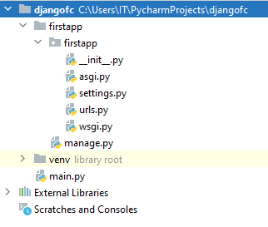
* Then Check whether your project is running successfully or not using **“python manage.py runserver”**
* 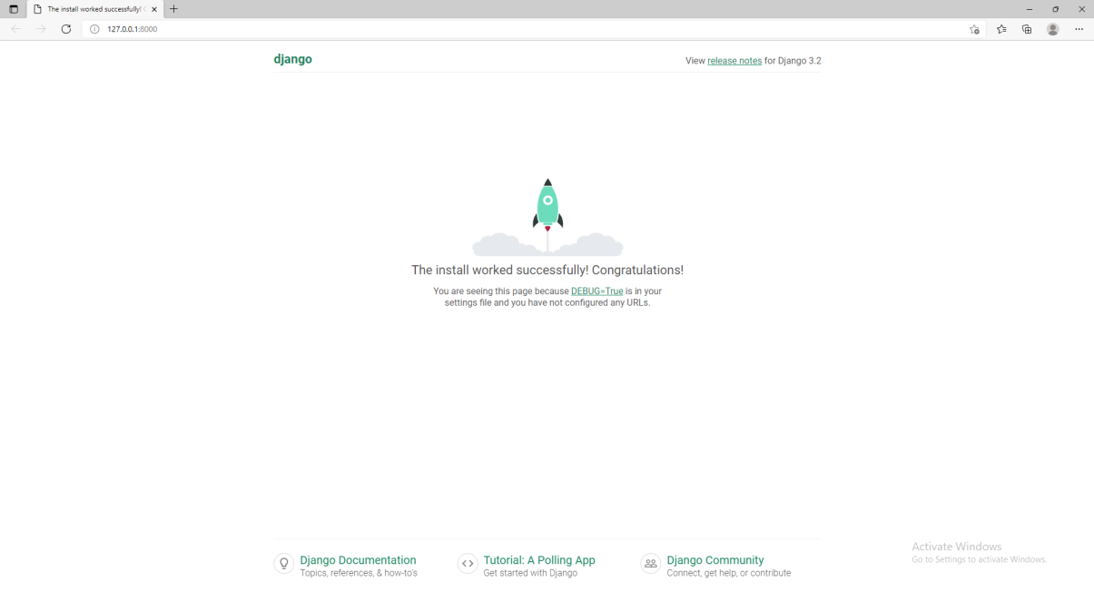
* When you can able to see this rocket, which is ready to take off. It means you have installed Django successfully.
* Then come back to pycharm and create a new app using **“python manage.py startapp session1”**
* 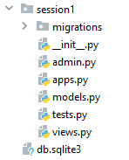
* Then Open **views.py** to write the code
* Add the following code

from django.shortcuts import render  
from django.http import HttpResponse  
  
def Courses(request):  
 return HttpResponse('<h1>This is my Home Page</h1>')

* Then to connect views.py with URLs create **urls.py** in your app
* Add the following code

from django.urls import path  
from . import views  
urlpatterns = [  
 path('',views.Courses,name='home-page'),  
]

* then we have to add this path in our main project urls (**firstapp**)
* open urls.py of firstapp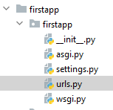
* then add following code

from django.contrib import admin  
from django.urls import path, include  
  
urlpatterns = [  
 path('admin/', admin.site.urls),  
 path('',include('session1.urls')),  
]

* Then Run the application in terminal using “**python** **manage.py runserver”**
* Then successfully created your app you will get output like

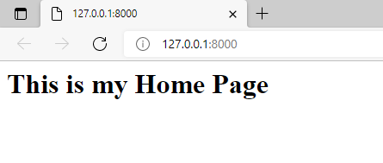

**Displaying Date & Time:**

* Add/Modify the views.py of session1

from django.http import HttpResponse  
import datetime  
  
def rk(request):  
 now = datetime.datetime.now()  
 html = "Time is {}".format(now)  
 return HttpResponse(html)

* Then Modify the urls.py

from django.urls import path  
from . import views  
  
urlpatterns = [  
 path('',views.rk,name='home-page'),  
]

